**Java to implement access modifiers**

**package** Access;

//1. Class is having Default access modifier

**class** defAccessSpecifier

{

**void** display()

{

System.***out***.println("You are using defalut access specifier");

}

}

**public** **class** Accessspecifiers1 {

**public** **static** **void** main(String[] args) {

//default

System.***out***.println("Dafault Access Specifier");

defAccessSpecifier obj = **new** defAccessSpecifier();

obj.display();

}

}

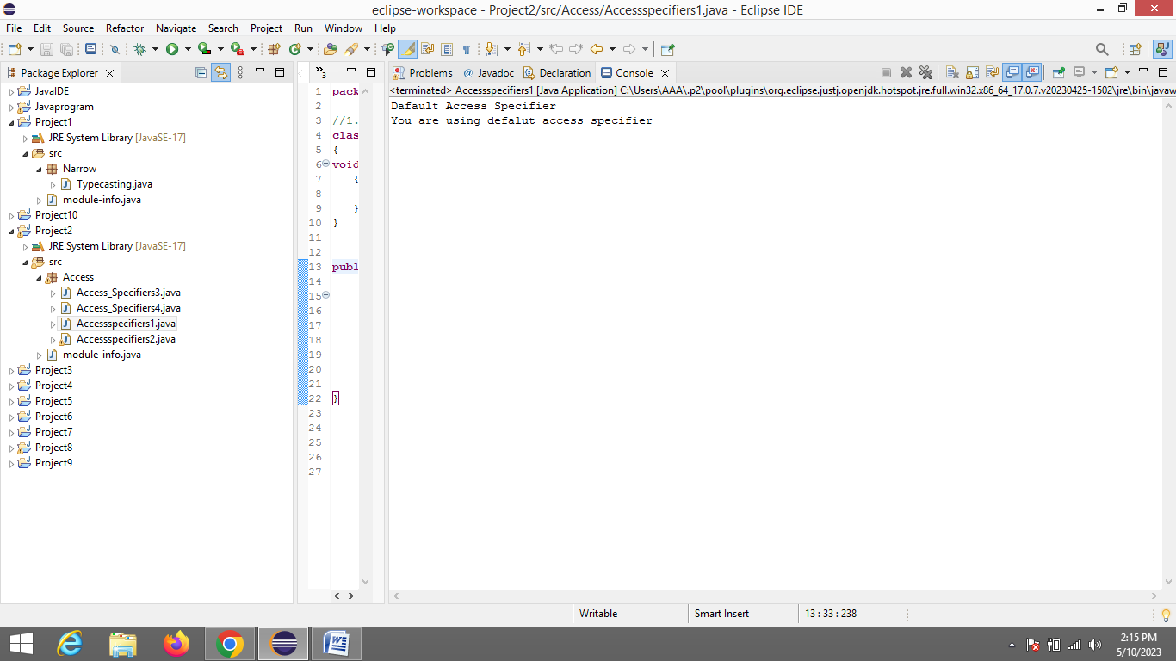

2) Private Access

**package** Access;

**public** **class** Accessspecifiers2 {

**private** **void** display ()

{

System.***out***.println("use private access specifier");

}

**public** **static** **void** main(String[] args) {

System.***out***.println("Private Access Specifier");

Accessspecifiers2 obj = **new** Accessspecifiers2();

}

}

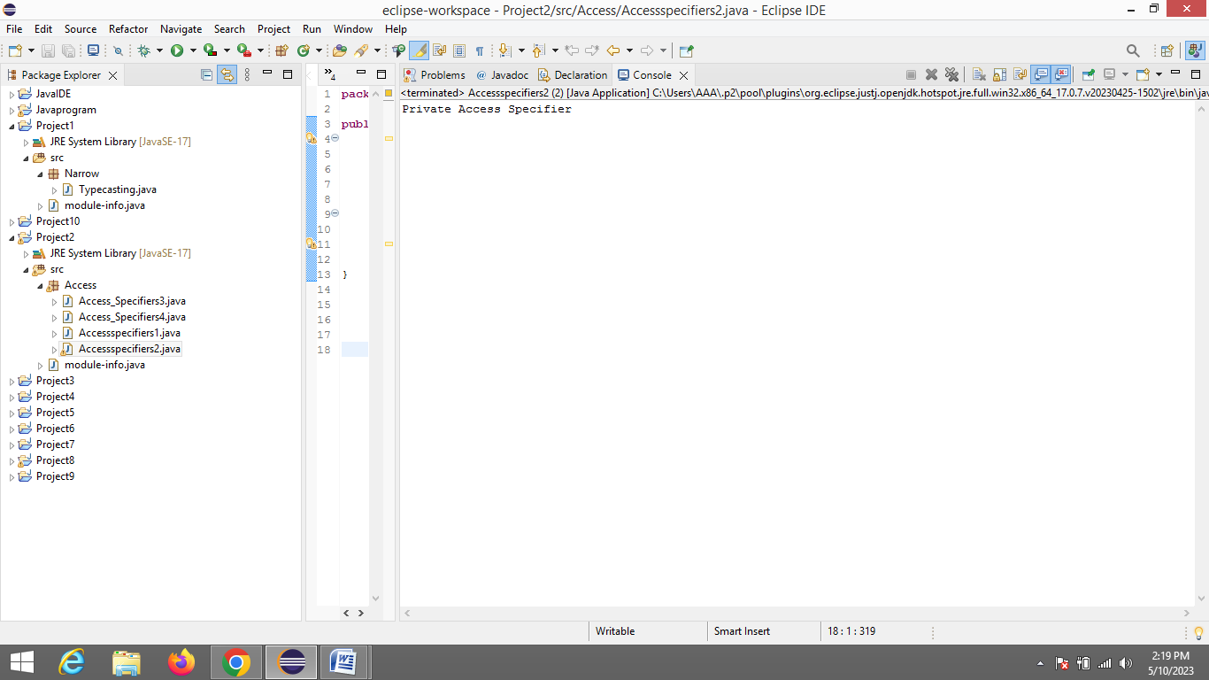

3) Protected Access

**package** Access;

**public** **class** Access_Specifiers3 {

**void** display()

{

System.***out***.println("Using protected access specifier");

}

**public** **static** **void** main(String[] args) {

//public

System.***out***.println("Protected Access Specifier");

Access_Specifiers3 obj = **new** Access_Specifiers3();

obj.display();

}

}

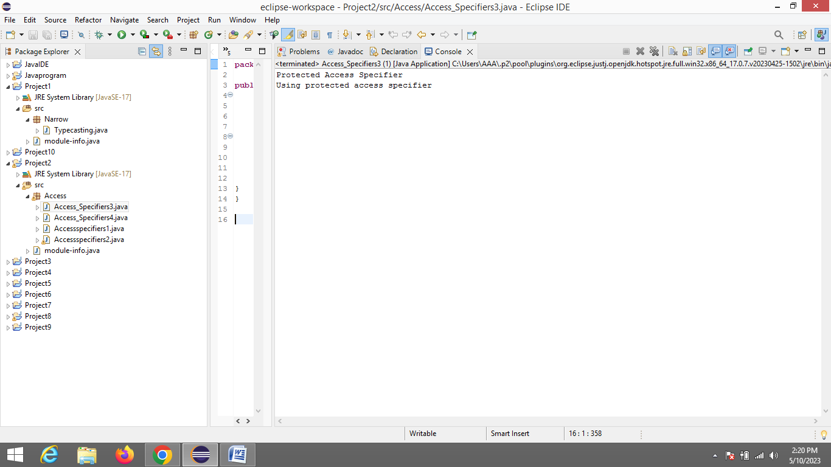

4) Public Access

**package** Access;

**public** **class** Access_Specifiers4 {

**void** display()

{

System.***out***.println("This is Public Access Specifiers");

}

**public** **static** **void** main(String[] args) {

Access_Specifiers4 obj = **new** Access_Specifiers4();

obj.display();

}

}

